Pharmacy Management and Control System (PMACS)

Use Case Specification Document

USCD-1.1
Ring Up Customer
Version No. 0.6

Project Document Revision History
Version Number | Date | Revision Author | Description of Revision
.1 | 2/27/17 | Alex Pope | Adding swimlane diagram and up-to-date logo to the document.
.2 | 3/1/17 | Alex Pope | Adding table of contents.
.3 | 3/5/17 | Alex Pope | Add new swimlane diagram including additional functions.
.4 | 3/7/17 | Alex Pope | Changed swimlane diagram based on project manager suggestions
.5 | 3/22/17 | Cindy Samano | Change Swimlane, and update documents to show those changes. Based on March 21, 2017 and March 22, 2017 meeting.
.6 | 4/27/17 | Cindy Samano | Final revisions.

Table of Contents
1. Introduction 4
2. Use Case Information 4
2.1 Actors 4
2.2 Use Case Interaction 4
3. Trigger 4
4. Pre-condition(s) 4
5. Post-condition(s) 4
6. Use Case Swimlane (Activity) Diagram 5
7. Main/Basic Flow(s) of Events (Happy Path) 5
8. Alternate/Exception Flow of Events 8
9. Assumptions/Business Rules including Non-Functional Requirements 10
10. Use Case Specification Review and Signoff 10

1. Introduction
This use case handles the interaction between a store cashier, the system, and an additional store employee. This use case is called when a transaction is in process with a customer. It will also be used to produce prescription labels, and create and modify customer accounts. The system will create identification numbers for new accounts and notify the cashier if a customer is eligible for a refill based on the information in their account. The additional employee must approve prescription refills when they are requested.

2. Use Case Information

2.1 Actors
Actor Name | Role | Description
Cashier | Main | Cashier running the transaction.
Other Employee | Secondary | Additional employee for the pharmacy for approval purposes.

2.2 Use Case Interaction
Sales Manager – Update -> predecessor.

3. Trigger
This use case is triggered during any transaction with a customer.

4. Pre-condition(s)

Items the customer is purchasing must be in the system.
    - Store must be already created in the system.

5. Post-condition(s)

Items purchased will be subtracted from stores inventory.

If customer is eligible for refill, the system will notify the cashier.

If the customer does not have an account, the cashier will prompt creation through the system.

Prescription labels will be created based off customer information.

6. Use Case Swimlane (Activity) Diagram 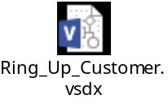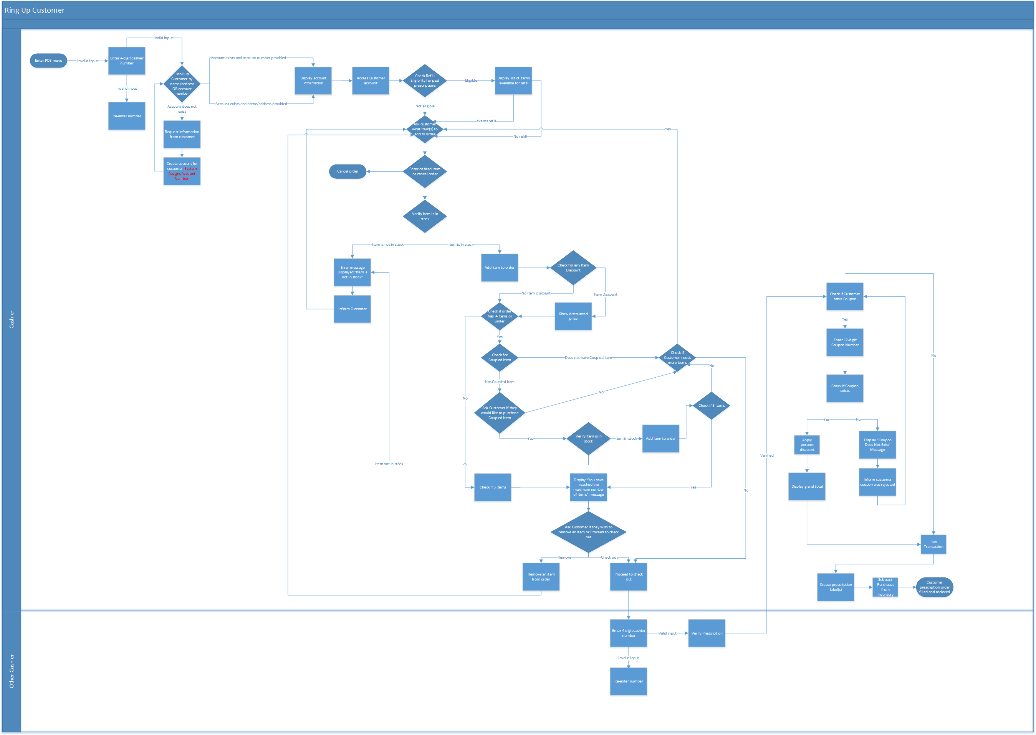

7. Main/Basic Flow(s) of Events (Happy Path)

Cashier Starts ringing up customer.

Cashier will look up the customer by name/address or account number.
  - Account exits provided account number.
    - Display name/address on order screen.
  - Account exits provided name/ address.
    - Display account number on order screen.
- Cashier accesses customer account with either account number or name/address.
- Customer is eligible for a refill on past prescription.
- Display list of items available for refill.
- Customer wants refill.
- Cashier will ask customer which items to add to order.
- Cashier will enter customers desired item.
- Item is in stock.
- Item added to order.
- Item has discount.
- Discounted price will appear on screen.
- Order has 4 items or under.
- Item has coupled item.
- Cashier will ask customer if they would like to purchase coupled item.
- Customer says yes.
- Coupled item is in stock.
- Item is added to the order.
- Order is not at 5 items.
- Cashier will check if customer needs more items.
- Flows 5.8 through 5.22 will be repeated until order reaches 5 items.
- Order reaches 5 items.
- Display “You have reached the maximum number of items” message.
- Cashier will ask customer if they wish to remove an item or proceed to check out.
- Customer wishes to proceed to check out.

Other cashier will approve and verify order.

Cashier will check if customer has coupon.

Customer has coupon.

Cahier will enter 12-digit coupon number.

Coupon exists.

Cashier will apply the percent discount. Display grand total.

Cashier will run transaction.

System will create prescription label(s).

Subtract purchases from inventory.

Customer prescription order filled and received.

8. Alternate/Exception Flow of Events
- Cashier will look up the customer’s account.
- Account does not exist.
- Cashier will request information from customer.
- Cashier will create an account for customer.
- Cashier will look up customer by name/address or account number

- Customer is eligible for refill.
- Display list of items available for refills.
- Customer does not want refill on items.
- Cashier will ask customer what items to add to order.

- Customer is not eligible for refill on past prescription.
- Cashier will ask customer what items to add to order.
- Cashier enters desired item
- Item is not in stock.
- Error message displayed “Item is not in stock”.
- Cashier informs customer.

- Cashier informs customer that item is out stock.
- Cashier asks customer what items to add to order.
- Customer wishes to cancel order.
- Order is canceled.

- Item does not have discount
- Check if order has 4 items or under.

- Item does not have coupled item.
- Cashier checks if customer need more items.

- Item has coupled item.
- Cashier asks if customer would like to purchase coupled item.
- Customer says no.

- Item has coupled item.
- Cashiers asks customer if they could like to purchase coupled item.
- Customer says yes.
- Item is not in stock.
- Error message displayed “Item not in stock”.
- Cashier informs customer.

- Order is not 4 items or under.
- Check for 5 items.
- Display “You have reached the maximum number of items” message.”
- Cashier asks Customer if they wish to remove an Item or Proceed to check out.
- Customer wishes to remove an item.
- Cashier will ask customer what item(s) to add to order.

- Customer wishes to proceed to check out.
- Other cashier will verify prescription.

- Cashier asks customer for coupon.
- Customer does not have coupon.
- Cashier proceeds to run transaction.

- Cashier asks customer for coupon.
- Coupon does not exist.
- Cashier informs customer coupon was rejected.

9. Assumptions/Business Rules including Non-Functional Requirements
POS System must run purchases in less than 5 seconds.

10. Use Case Specification Review and Signoff
Name | Project Team Role | Signature | Date
Erik Johnson | Team Lead | EJ | 3/24/17
Durwin Johnson | Developer | DJ | 3/24/17
Alex Pope | Developer | AP | 3/24/17
Cindy Samano | Developer | CS | 3/24/17
Fnu Jirigesi | Project Manager | FJ | 3/24/17
Erik Johnson | Team Lead | EJ | 4/27/17
Durwin Johnson | Developer | DJ | 4/27/17
Alex Pope | Developer | AP | 4/27/17
Cindy Samano | Developer | CS | 4/27/17
Fnu Jirigesi | Project Manager | FJ | 4/27/17
Wenhao Zhang | Project Manager | WZ | 4/27/17

